THE MNCWASA WATER SCHEME SURVEY PLAN

BACKGROUND
The Mncwasa Water Scheme building started in 2010 and was finalised around 2013. The Scheme changed the lives of the people in this region. Access to quality, clean water near households brought along with-it improved health outcomes, reduced infant mortality, and increased the quality of life for all.
The Scheme feeds water to approximately 6000 households across 40 villages, has 32 reservoirs: hundreds of break-pressure tanks and thousands of taps.
While this is an access to water services success story for post- democratic South Africa, maintaining and ensuring consistent and reliable access to clean water is becoming an increasing challenge. Although most of the villages have access to communal taps, there are areas that have not had access to water for months, many taps that are not operational and there are many leaks all around the system. There are also some homesteads that do not have a tap within 200 metres of their home as legally required.
In April 2020, the Bulungula Incubator and Equality Collective set up a WhatsApp group to facilitate community leaders reporting issues to the Amathole District Municipality (“ADM”). The assumption was that the main problem/ issue was a lack of reporting. However, it was quickly realised that some of the issues were structural and/or systemic and that a more comprehensive diagnosis of the challenges was required. We then resolved to conduct a Survey of the Mncwasa Water Scheme to support a technical enquiry by experienced engineers.
The Survey was conducted as a joint venture between the Equality Collective and Viva con Agua with the support of the Bulungula Incubator; the Jalamba Traditional Council and ADM as well as support from various community leaders, representatives, and counsellors.
The survey was planned with guidance and technical input and support from Wayne Ketteringham and Jim Gibson. Wayne Ketteringham reviewed the technical data and provided the recommendations for remedial measures. We acknowledge and appreciate both members of the technical team who have dedicated their time in support of this survey on a pro bono basis.

PURPOSE
The primary purpose of the survey was to capture all the current challenges/issues hampering water service delivery in the region. We have captured these below and intend to use the issues identified, together with remedial measures proposed to further engage ADM on a way forward.

COMMUNITY SURVEY

APPROACH
A short, pointed community questionnaire was designed to identify which villages have water and how regular that water access/supply is; how many taps there are in each village, how many taps are/are not working across villages; why some taps do not have water; the quality of water since the scheme was first built, whether the main reservoir is overflowing or leaking; whether any of the brake pressure tanks are not working, overflowing or leaking; and whether communities regularly report issues to ADM, leadership structures or counsellors and the response time to fix reported faults. A final draft of the questionnaire can be found in Annexure A.
A small team of 6 surveyors were trained and the survey was conducted over a period of 5 days from 30 March – 5 April 2021. 32 reservoir supply areas were evaluated, 297 interviews were conducted (an average of 9 per reservoir supply area) and the interviews provided information regarding approximately 941 taps.
The following map provides detail of the area surveyed: indicating the reservoir number and supply area per reservoir.
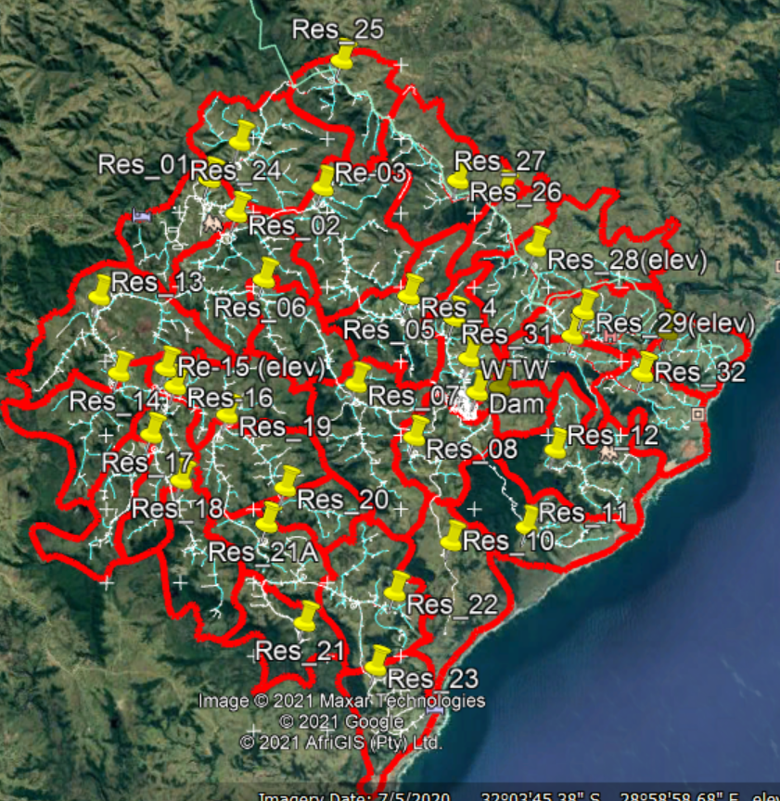
Figure 1: Mncwasa Water Scheme Reservoir supply areas (Source: Google Earth)
The table below breakdowns the number of taps per reservoir area and village that were surveyed as part of our interviewee process:
Number of taps per reservoir
Res No. | Village | Total No. Taps
1 | Tafelehashe | 31
2 | Dlova | 2
 | Tafelehashe | 24
3 | Kotyana | 14
 | Other | 22
4 | Kotyana | 28
5 | Kotyana | 14
6 | Other | 17
7 | Dlova | 9
 | Other | 38
8 | Bhawu | 7
 | Dlova | 11
 | Mpame | 7
 | Mpame Bhawu | 6
 | Nxaxu | 8
 | Other | 4
9 | Other | 9
10 | Other | 26
11 | Mpame | 6
 | Other | 17
12 | Mdikana | 28
 | Other | 6
13 | Other | 35
14 | eNgojini | 25
 | Other | 9
15 | Gobene | 35
16 | Manaleni | 9
 | Mgojweni | 1
 | Other | 15
17 | Emboleni | 32
18 | Mgojweni | 12
 | Nditya | 3
 | Other | 5
19 | Gobene | 35
20 | Kwandiya | 11
 | Nditya | 2
21 | Folokwe | 11
21A | Mazizini | 22
22 | Ntilini Tshezi | 5
 | Tshezi | 26
23 | Other | 30
24 | Bufumba | 35
25 | Other | 18
26 | Other | 9
 | Twalimofu | 38
28 | Other | 18
 | Zithulele | 12
29 | Zithulele | 79
30 | Mhlahlane | 21
31 | Giyintsimbi | 16
32 | Botho | 20
 | Botho Lubanzi | 4
 | Lubanzi | 3
 | Mbemyu Lubanzi | 5
 | Tafelehashe Lubanzi | 6
 |  | 941

SUMMARY OF SURVEY ANAYSIS
The Overall analysis is broken into two sections. Section A focuses the access to water (taps) while Section B focuses on the water supply (reservoirs).

SECTION A: WATER AND TAPS
The following provides a summary of the (a) availability and reliability of water, (b) tap functionality, (c) quality of water and (d) reporting of faults for the entire area. A more detailed analysis of the water scheme will be provided per reservoir.
- Availability of Water
When asked if there is water available on the day the interview was conducted, 55% (162 respondents) indicated that there was no water available (‘no’) while 42% (126 respondents) indicated that there was water available (‘yes’). 9 respondents (3%) selected ‘other’ noting that there are ‘no taps’ around their homestead.
When asked if water is available every day, 82% (243 respondents) indicated ‘no’ while only 14% (43 respondents) indicated ‘yes’. 11 respondents (4%) selected ‘other’, with two stating that the ‘taps are locked’ and 9 noting there are ‘no taps’.
The table below provides detail of the 9 respondents that indicated there are no taps for both of the above questions:
Res No. | Village | Area | Latitude | Longitude
5 | Kotyana | Sikhroboxeni | -32.0490117 | 29.0116634
8 | Mpame | Manzibomvu | -32.0694584 | 29.0252956
21 | Folokwe | Ematyeni | -32.1177562 | 28.9668344
26 | Putuma | Mthala | -32.0171003 | 29.0253201
26 | Putuma | Mthaleni | -32.0231945 | 29.035236
26 | Putuma | Mpako | -32.0215754 | 29.0379318
28 | Zithulele | Good hope | -32.0301711 | 29.0448037
28 | Zithulele | KwaQulu | -32.0325728 | 29.0398799
29 | Zithulele | Nxwangu | -32.0478709 | 29.064059

The 243 respondents that indicated that water is NOT available every day, when asked to explain when they last received water and could choose one of the following answers: I cannot remember, last week, last month or other. 34% did not provide an answer while 41% (99 respondents) noted “Other” and indicated that they last received water over a year ago (‘since last year’). 11% noted that they last received water ‘last week’ (this is likely due to the Eskom issues experienced affecting the workability of the pump when the survey was conducted).
The table provides a detailed breakdown of the responses:
No response | 83 | 34%
Since last year | 99 | 41%
Last week/kuleveki iphelileyo | 28 | 11%
Since 2019 | 10 | 4%
Since the tap was broken | 6 | 2%
Surveyor cannot remember | 4 | 2%
I cannot remember/Andisakhumbuli | 4 | 2%
Last month/kulenyanga iphelileyo | 4 | 2%
Since 2018 | 2 | 1%
Locked tap(s) | 1 | 0%
No taps | 1 | 0%
Since 2013 | 1 | 0%
Three months ago | 1 | 0%
 | 244 | 100%

Additionally, the 244 respondents that indicated that water is NOT available every day, were asked to explain how often they received water and could choose one of the following answers: usually, sometimes, seldom, never, and other.
Half of the respondents (50%) indicated that they ‘never’ receive water, 47% noted that they ‘seldom’ receive water, only four respondents (2%) indicated ‘sometimes’. One respondent did not indicate a response and one respondent selected ‘other’ with the following explanation:
“The tap at the bottom of the hill gets water frequently, the taps at the top of the hill rarely get water “.
This is a clear indication that reservoirs never fill/ the supply is starved.
80% of the respondents noted that the supply of water is ‘less reliable’ since the scheme was first built, while 10% noted the water supply as the ‘same’, 6% were ‘unsure’ of the water supply and only 1% noted the water supply as ‘more reliable’ since the scheme was first built. The 3% who selected ‘other’ noted that they do not have access to taps.
For those 239 respondents (80%) who noted that the scheme is less reliable, some explanations were provided. These responses can be found in the data set.
Critical Supply Areas
Broken down per reservoir and weighting the answers to “is there water available today”; “is water only available for part of the day” and “how reliable is the scheme since it was first built”, the critical supply areas can quickly be identified.
 |  |  |  | Weighting Factors |  |  | Index
Res | No Water Today | Only Part of Day | Unreliability | 1 | 2 | 3 | Index
32 | 100% | 100% | 100% | 1,00 | 2,00 | 3,00 | 6,00
25 | 100% | 100% | 100% | 1,00 | 2,00 | 3,00 | 6,00
24 | 100% | 100% | 100% | 1,00 | 2,00 | 3,00 | 6,00
29 | 93% | 93% | 100% | 0,93 | 1,86 | 3,00 | 5,79
1 | 92% | 100% | 92% | 0,92 | 2,00 | 2,77 | 5,69
4 | 100% | 100% | 88% | 1,00 | 2,00 | 2,63 | 5,63
31 | 86% | 100% | 86% | 0,86 | 2,00 | 2,57 | 5,43
28 | 78% | 78% | 100% | 0,78 | 1,56 | 3,00 | 5,33
3 | 100% | 100% | 78% | 1,00 | 2,00 | 2,33 | 5,33
30 | 67% | 100% | 67% | 0,67 | 2,00 | 2,00 | 4,67
26 | 100% | 100% | 43% | 1,00 | 2,00 | 1,29 | 4,29
11 | 50% | 100% | 50% | 0,50 | 2,00 | 1,50 | 4,00
6 | 50% | 100% | 50% | 0,50 | 2,00 | 1,50 | 4,00
16 | 67% | 100% | 40% | 0,67 | 2,00 | 1,20 | 3,87
26 (27) | 43% | 43% | 86% | 0,43 | 0,86 | 2,57 | 3,86
23 | 55% | 91% | 36% | 0,55 | 1,82 | 1,09 | 3,45
15 | 42% | 100% | 33% | 0,42 | 2,00 | 1,00 | 3,42
17 | 54% | 77% | 31% | 0,54 | 1,54 | 0,92 | 3,00
14 | 89% | 100% | 0% | 0,89 | 2,00 | - | 2,89
2 | 71% | 100% | 0% | 0,71 | 2,00 | - | 2,71
21 | 29% | 100% | 14% | 0,29 | 2,00 | 0,43 | 2,71
13 | 17% | 100% | 17% | 0,17 | 2,00 | 0,50 | 2,67
10 | 14% | 100% | 14% | 0,14 | 2,00 | 0,43 | 2,57
19 | 50% | 100% | 0% | 0,50 | 2,00 | - | 2,50
21A | 18% | 82% | 18% | 0,18 | 1,64 | 0,55 | 2,36
9 | 75% | 75% | 0% | 0,75 | 1,50 | - | 2,25
5 | 0% | 75% | 25% | - | 1,50 | 0,75 | 2,25
20 | 0% | 100% | 0% | - | 2,00 | - | 2,00
22 | 20% | 40% | 20% | 0,20 | 0,80 | 0,60 | 1,60
7 | 9% | 55% | 9% | 0,09 | 1,09 | 0,27 | 1,45
8 | 0% | 15% | 8% | - | 0,31 | 0,23 | 0,54
18 | 0% | 0% | 0% | - | - | - | -
12 | 0% | 0% | 0% | - | - | - | -

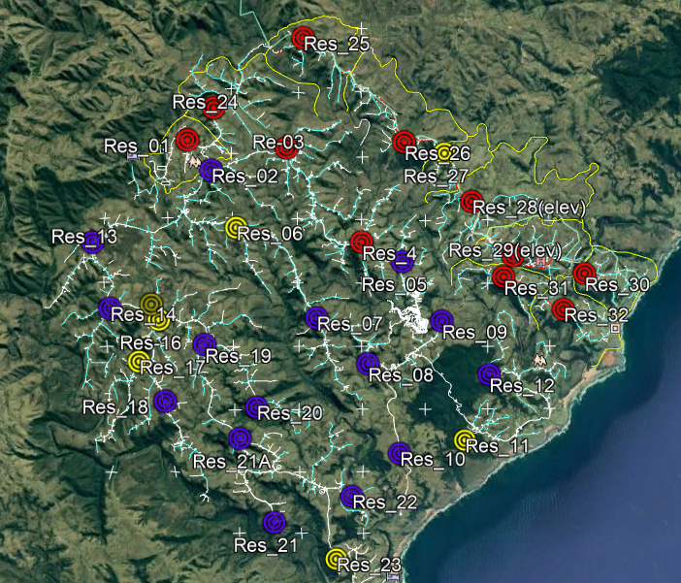
There is decreasing functionality as you move from south -south west (blue) to north - north east (red) across the scheme. The line across the scheme, and then down to Zithulele is clearly problematic.

- Tap Functionality
The respondents were asked how many taps were around their homestead and asked how many were working and how many were not working. The table below provides a total for the number of taps surveyed per reservoir as well as the total number of taps indicated as working and not working.

Res No. | No. Taps | Taps Working |  | Taps Not Working
1 | 31 | 1 | 3% | 30 | 97%
2 | 26 | 4 | 15% | 22 | 85%
3 | 36 | 0 | 0% | 36 | 100%
4 | 28 | 0 | 0% | 28 | 100%
5 | 14 | 9 | 64% | 5 | 36%
6 | 17 | 9 | 53% | 8 | 47%
7 | 47 | 30 | 64% | 17 | 36%
8 | 43 | 33 | 77% | 10 | 23%
9 | 9 | 2 | 22% | 7 | 78%
10 | 26 | 12 | 46% | 14 | 54%
11 | 23 | 11 | 48% | 12 | 52%
12 | 34 | 33 | 97% | 1 | 3%
13 | 35 | 19 | 54% | 16 | 46%
14 | 34 | 1 | 3% | 33 | 97%
15 | 35 | 19 | 54% | 16 | 46%
16 | 25 | 5 | 20% | 20 | 80%
17 | 32 | 14 | 44% | 18 | 56%
18 | 20 | 16 | 80% | 4 | 20%
19 | 35 | 8 | 23% | 27 | 77%
20 | 13 | 7 | 54% | 6 | 46%
21 | 11 | 8 | 73% | 3 | 27%
22 | 31 | 17 | 55% | 14 | 45%
23 | 30 | 9 | 30% | 21 | 70%
24 | 35 | 0 | 0% | 35 | 100%
25 | 18 | 0 | 0% | 18 | 100%
26 | 47 | 2 | 4% | 45 | 96%
28 | 30 | 0 | 0% | 30 | 100%
29 | 79 | 0 | 0% | 79 | 100%
30 | 21 | 4 | 19% | 17 | 81%
31 | 16 | 1 | 6% | 15 | 94%
32 | 38 | 0 | 0% | 38 | 100%
21A | 22 | 12 | 55% | 10 | 45%
 | 941 | 286 | 30% | 655 | 70%

The following table provides a summary of the reasons identified by the respondents why the taps are not working. Only 189 (29%) out of the 655 taps that were identified as not working, are broken. 69% or 454 taps are fine but have no water, while two taps have leaking pipes and 10 of the taps are locked.
No Water, Tap is fine | 454 | 69%
Broken Taps | 189 | 29%
Leaking Pipes | 2 | 0%
Locked Taps | 10 | 2%
 | 655

A list of the broken taps and their locations can be found in Annexure B. Annexure C details the location all the areas where interviewees indicated taps were not working and their description for why not.
In general, if the taps are not working most respondents indicated that their preferred alternative option is to get water from the river (65%), while some access water from a spring (32%) and only a few indicated that they collect water from a borehole (4%).
- Quality of the water
97% of the respondents noted that the quality of the water is good. The 3% (8respondents) that indicated ‘other’, do not have access to taps.

The respondents were asked to describe the quality of the water by focusing on the smell, taste, and water clarity.
- 96% (286 respondents) noted that the water smells okay, with only 3 respondents indicated that it does not smell okay.
- 97% (289) indicated that the water tastes okay.
- 97% (289 respondents) indicated that the water is clear.
The 8 respondents that do not have access to taps indicated other for all the above answers.
- Reporting of Faults
84% of respondents, the overwhelming majority, have never reported an issue regarding water, despite there being significant reliability issues. Only a small percentage, 13% have ever reported an issue. The 3% that indicated ‘other’ do not have access to taps.

The 40 respondents that indicated ‘yes’ to reporting a fault, mainly reported issues to ward counsellors. The pie chart provides a breakdown of the fault reporting channels:

Only 37.5% (15 respondents) indicated that the fault was resolved after reported. Of those 15 respondents, four reported to the traditional leadership, nine to the ward counsellor, one to the mayor and one to the ward committee.
Out of the 40 respondents, just over half (53%) indicated that the faults are ‘never’ resolved. Of the faults that were resolved, more than half (58%) said it took ‘a week’ to resolve, while a third (32%) said it took ‘a month’ to resolve.

- Salient findings for Section A
The above summary indicates the following for the Mncwasa water scheme:
- The overwhelming majority of the respondents indicated that the water tastes, smells and looks fine. There appears to be no cause for concern regarding the quality of the water being delivered from the Mncwasa Water Scheme.
- There are, however, clearly concerning water availability issues from the Scheme. On the day surveyed, over half of the respondents (55%) indicated that there was not water available and 82% of respondents indicated that water is not available every day. Of those who indicated that water is not available every day, 41% indicated that they had not had water since last year.
- It is evident from the surveys that the availability and reliability of water decreases as you move from south -south west (blue) to north - north east (red) across the scheme. The line across the scheme, and then down to Zithulele is where the problem manifests itself. Please see engineer inputs below.
- Of the taps that are not delivering water, one third were indicated as broken.
- It is also evident that our communities are disempowered and not reporting water issues to the relevant authorities.

SECTION B: RESERVOIRS AND BREAKWATER PRESSURE TANKS
This section provides a summary of the reservoirs and breakwater pressure tanks that were either leaking or overflowing on the days of the inspection.
- Reservoirs: leaking/overflowing
Reservoir 15 and 21A were identified as overflowing. Both have already been reported to the municipality and resolved. These flow rates by observation are relatively high and significantly high in relation to the volume of water required by a village over a 24hour period. The overflowing here will impact supplies to all upstream villages.
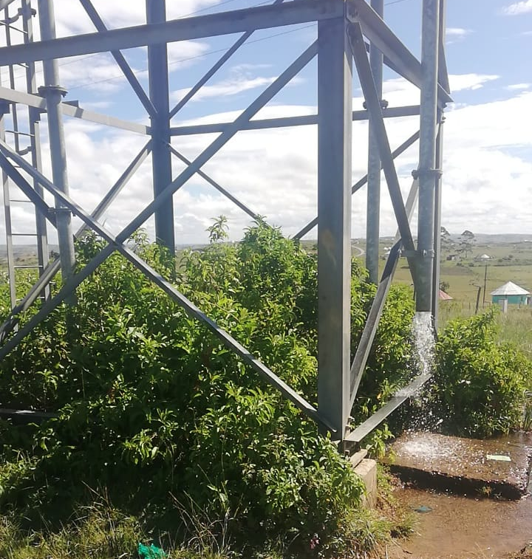
Reservoirs 16 and 28 were identified as having no water flowing inside. These are high lying reservoirs.
Res 21A
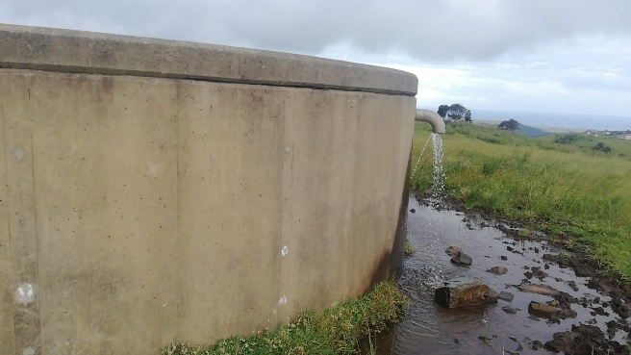
Res 15

- Water availability
31% of interviewees indicated that water was only available for part of the day. Of those who indicated ‘yes’:
- 59% said the water was only available in the “morning”
- 20% said it was only available in the “afternoon”
- 2% said it was available in the “morning” and “afternoon”
- 12% said it was only available at “night”.

The reliability of this data is likely doubtful as many answered differently within the same supply area. However, the following trends (where four or more interviewees indicated similarly) were noticeable:

Res No. | If yes, which part of the day
Res 1 | Morning/Kusasa Afternoon/Emalanga
Res 2 | Morning/Kusasa
Res 8 | Afternoon/Emalanga
Res 13 | Morning/Kusasa
Res 14 | Morning/Kusasa
Res 15 | Morning/Kusasa
Res 17 | Morning/Kusasa Afternoon/Emalanga
Res 22 | Morning/Kusasa
Res 26 | Morning/Kusasa
A reason for some areas saying “morning/kusasa” is likely because the system probably fills overnight when use is low and therefore water is available in the morning. Res 8 is an anomaly, probably implies system filling from the bottom-up/BPT starting to restrict flows.
- Brake pressure tanks: leaking/overflowing
A breakdown of the brake pressure tanks with leaks identified and those not working are included below:
No. | Latitude | Longitude | 4. Is the Brake Pressure Tank overflowing or leaking | 4.2 If Other, please explain
1 | -32.1217877 | 28.9716835 | Yes/Ewe
2 | -32.1458403 | 29.0008571 | Other/Enye | There is no water flowing through the BP tank
3 | -32.1183384 | 28.9694942 | Yes/Ewe
4 | -32.1072755 | 29.0146608 | Other/Enye | It appears that it cannot pump well to the taps
5 | -32.1217765 | 28.9716375 | Yes/Ewe
6 | -32.0640077 | 29.0690906 | Other/Enye | There is no water flowing through the BP tank
7 | -32.0674007 | 28.9993845 | Yes/Ewe
8 | -32.0487032 | 29.0116237 | Yes/Ewe
9 | -32.0784556 | 28.922958 | Yes/Ewe

- BPTs 1,5 &3 are Reticulation BPT’s and fall within the supply zone of Res 21. Both are leaking.
- BPT 2 is a Reticulation BPT and falls within the supply zone of Res 23.
- BPT 4 is a Reticulation BPT and falls within the supply zone of Res 10.
- BPT 6 is a Reticulation BPT and falls within the supply zone of Res 32.
- BPT 7 is a Reticulation BPT and falls within the supply zone of Res 7. The BPT is leaking.
- BPT 8 is a Reticulation BPT and falls within the supply zone of Res 5. The BPT is leaking.
- BPT 9 is a Reticulation BPT and falls within the supply zone of Res 17. The BPT is leaking.

- Salient findings for Section B
The above summary indicates the following for the Mncwasa water scheme:
- A significant number of overflowing Reservoirs and leaking BPT’s were observed.
- It is to be noted that these Reservoirs & BPT’s are all located on the so called “functional” side of the Scheme. This probably implies that there are also a significant number on the “non-functional” side, they just could not be observed due to inadequate water supplies during the days of the survey.

ENGINEERS ASSESSMENT OF SCHEME

APPROACH
The approach adopted included the following:
- Visual inspection of parts of the works (Water treatment plant, Res 01 & Res 06);
- Interviews with ADM O&M staff and contractors;
- Collation of as-built data; and
- Importation of as-built record into Google Earth and review of same.
It was intended to undertake a hydraulic analysis of the bulk supply network of the Scheme, but inadequate as-built record could be obtained for such an exercise. In particular, key attribute data on the Bulungula & Zithulele legs was not obtained. Nevertheless, we feel that we have enough information to proceed and make concrete recommendations to the ADM team.

DESCRIPTION OF SCHEME
Water stored in an in-channel earth dam is pumped to a raw water holding dam in proximity of the water treatment plant (WTP). Raw water from the holding dam is gravity fed to the WTP (RL = 177m), where it is treated and pumped to the Command Reservoir (Res-01; RL=420m; +/- 243m static head) located some 10.5km north west of the WTP. The WTP has a reported capacity of 2.5Ml/d. The 3 potable water high lift pumpsets work on a 2-duty; 1 standby arrangement under normal circumstances. The delivery capacity is approx. 15 l/s with 1 duty pumpset and approx. 28l/s with 2 duty pumpsets.
Potable water is gravity fed from Res-01 to service village reservoirs located on the following 4 main supply legs of the scheme:
- Zithulele;
- WTP;
- Mpame; and
- Bulungula.
The Scheme is characterised by the use of village reservoirs primarily with bulk supply inlets only (i.e., no bulk supply outlets) and the use of specific Break Pressure Tanks (Variant or similar) for flow control, as well as for pressure reduction. These BPT’s comprise low volume steel tanks with control valve on the inlet, as well as separate dedicated outlet and overflow, and have also been installed within certain of the reticulation networks, primarily for pressure reduction.
See Annexure D for schematic layouts of the bulk components/network of the scheme.

FINDINGS FROM SITE INSPECTION & SUBSEQUENT ENAGAGEMENTS

It has been reported that the raw water system (from the dam to WTP) is generally functional and is therefore not discussed further in this report.

Key findings which would impact the sustainability/reliability of supplies include the following:
- Eskom supplies are not secure (load shedding; phase imbalance) and therefore the WTP & pumpsets cannot necessarily operate 24/7/365;
- There was (is) only 1 functional duty pumpset; i.e., delivering +/- 55% of design capacity;
- Certain of the reservoirs overflow; and
- The BPT’s, both on the bulk and reticulation networks, overflow/fail regularly.
The net effect of the above is that the Scheme is operating well below capacity, i.e. at most 55% of the design volume of water is put into the Scheme on a daily basis and then there is water loss/wastage through overflowing reservoirs, leaking BPT’s and broken/leaking taps. It is also highly probable that there are taps inadvertently left open at times, as well as pipe leaks in both the bulk and reticulation networks.

HIGH LEVEL ASSESMENT OF THE DESIGN/FUNCTIONALITY OF THE SCHEME
In the absence of key Scheme attribute data and detailed hydraulic modeling of the Scheme, only a first order assessment of the design and flow control/functionality of the Scheme can be undertaken. The key findings include:
- The design of the Scheme is based on the assumption that the bulk supply networks (pipelines & reservoirs) are kept “full” all or most of the time;
- Res 24 (start of Zithulele leg), including the take-off thereto, are at GL=>415m; i.e., the water level in Res-01, as well as the backpressures at the first of the BPT’s on each of the 3 other main supply legs, must be at least at these levels for the Zithulele leg to start receiving water. Therefore, without manipulating flows (e.g., throttling isolating valves; installing additional flow control);
  - The other 3 legs will probably need to fill first before the Zithulele legs starts to get water; and
  - Any failure of the BPT’s (or any material water loss/wastage) on any of these main supply legs will probably prevent the Zithulele leg from getting water.
- The Bulk pipelines are generally sized such that their internal velocities under design flows are generally 0.6 m/s or less. This implies that the flow capacities of the bulk pipelines are likely to be materially greater than the design flow when under free flow conditions (e.g., when a reservoir or BPT is overflowing or there is a leak); i.e. the “demand” for water from an overflow or leak, without provision additional flow control, is likely to be way in excess of the design flow. This will result in the water being “drawn” to the overflow/leak and prevent water from being “directed’ to the other supply areas.
These assessments correlate closely with the findings of the community survey.

CONCLUSIONS & RECOMMENDATIONS

CONCLUSIONS
The key conclusions which can be drawn from the above include:
- The Scheme is seldom if ever full or near full and is seldom kept in a filling mode for long enough for the Scheme to materially fill;
- The flow controls on the Scheme are such that an equitable distribution of the water in this “unfilled” situation is not possible;
- This situation is exacerbated by overflowing reservoirs, leaking BPT’s & taps and the likes;
- Village reservoirs, particularly those in the high laying parts of the Scheme, are therefore seldom ever full. This in-turn negatively impacts supplies to villages standpipes/taps, particularly those in the high laying parts of a reservoir supply zone;
- Several of the taps are broken in some respects;
- Faults on the Scheme, even if reported, appear to take unduly long to be remedied;
- The majority, if not all, of the Mncwasa communities are not receiving RDP compliant water supplies; and
- The Mncwasa communities appear not to be adequately empowered, and/or no formal communicating channels exist, to raise supply concerns to the relevant authorities.

RECOMMENDATIONS
- This report be presented to the ADM for them to develop a comprehensive response thereto including:
  - Addressing all readily identifiable faults e.g., broken taps & reservoir/BPT control valves;
  - Ensuring 2 duty pumpsets are operational at all times;
  - Ensuring the Eskom phase imbalance challenges are addressed and/or standby power generation capacity is provided; and
  - Routine monitoring and reporting, as well as repair and maintenance systems, be established. (NB early warning & rapid response to overflows, leaks & waste)
- The Equality Collective and Viva con Agua in partnership with the Bulungula Incubator, Jalamba Traditional Council, other political leaders and ADM should devise a longer-term strategy to improve community monitoring and reporting.
- Judicious flow control within the scheme is required.
- A second pipeline from the command reservoir, with its own outlet, to the Zithulele T-off, is recommended to ensure an equitable water supply to the Zithulele leg.
- Ongoing monitoring and operation are required (perhaps daily). It cannot be 'switched on' and be expected to operate in some form of equitable hydraulic balance.
- ADM will need to put the operational resources in place to ensure that the scheme 'behaves itself'.
- I would recommend the appointment of local operators to act as eyes and ears and to carry out operational and minor repair functions. (of course, how they are engaged by ADM may be difficult as the job would be very part time and ad-hoc)
Additional comments
- The continued and sustained operation of the pumpsets is critical.
- Early identification and repair of overflows/leaks is critical.
- Community awareness re negative impacts of overflows, leaks & wastage (taps left open) is critical.
- Early identification and reporting of low water levels in key reservoirs is critical.
- Periodic engagement with local ADM staff on supply challenges/scheme performance monthly) is recommended.
- Periodic engagement with senior ADM management its Scheme performance/supply challenges (6-months) is recommended.

Reservoir 27 could not be located either on google earth or in field and is unlikely to exist. It is understood that the Reservoir 27 supply zone has been incorporated into Reservoir 26’s supply zone.
The number of taps indicated in the table were not surveyed individually but rather calculated from the respondent’s interview when asked how many taps are in their area.
This was interviewees noting that there are “no taps” around their homestead.
We were promptly informed about these issues by ADM during the Survey and decided, after consultation with the engineers, to proceed and conduct the survey anyway.

